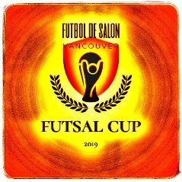
VANCOUVER FUTSAL CUP
Vancouver Futsal Cup November 9th-10th 2019 !

The Vancouver Futsal Cup will launch this November as a fully sanctioned by the newly formed British Columbia Futsal Association. The Cup will compete in one division (Open) in 2019 with round robin series and knockout. We are seeking 8 teams from Washington, Oregon and British Columbia, collectively. 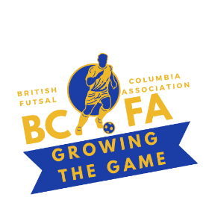
The Cup will be a prelude for much-anticipated league that kicks off the weekend end of November. The first Vancouver Futsal Cup kickoff tournament will be on Weekend November 9th 10th at UBC Osborne Centre in beautiful Vancouver , BC. This event will feature a full day of futsal matches followed by a presentation for the Prize Winners.

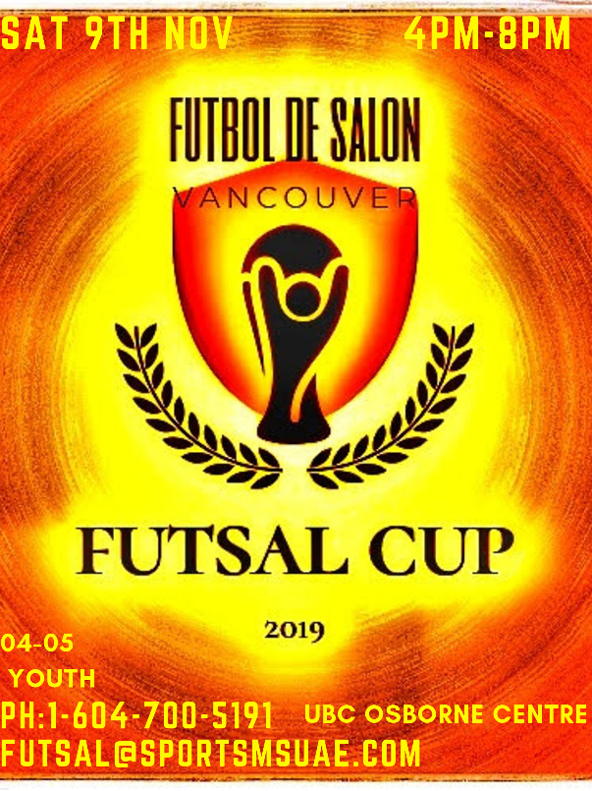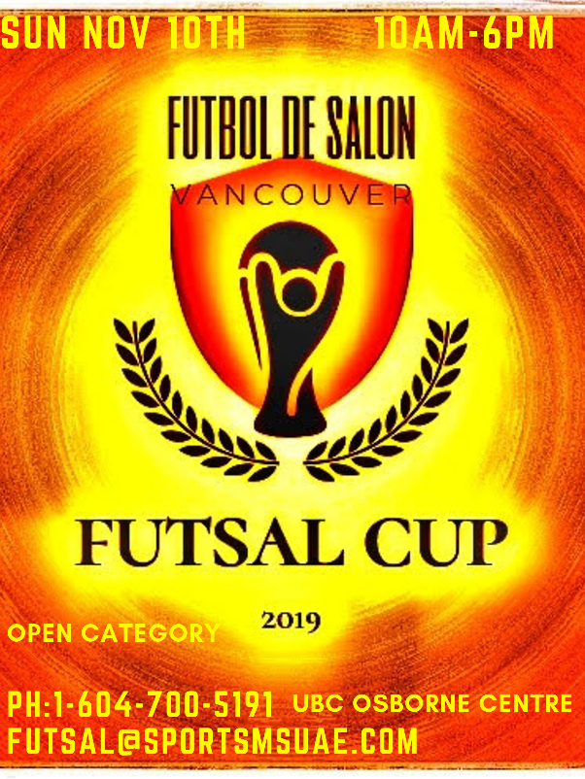

Cup Details:
- 9th 10th November
- Teams will play round robin matches games.
- rules to be released
- Teams will play a minimum of 3 matches on tournament day..
- Tournament fee is $350
- Early Registration Fee
$300 & VOLO TRAINING FUTSAL BALL VALUED $50 (FREE OF CHARGE)

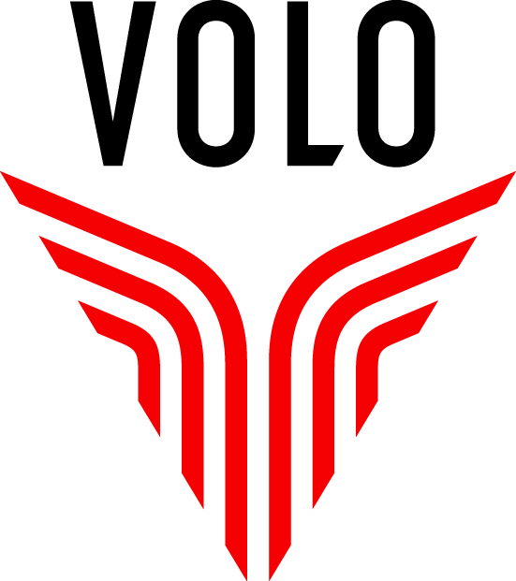 OFFICIAL BALL SPONSOR

OFFICIAL ATTIRE SPONSOR

Robert Osborne Centre GYM A Location for EVENT

VANCOUVER FUTSAL CUP

Application

Team Application Information

Team Name:
Category

Team Manager/Coach Name: |  |  |  |  |  |  |  | Title:
Phone: |  |  |  |  |  | E-mail:

Send contract to:
futsal@sportsmsuae.com
Interac payment
faris@sportsmsuae.com
password: futsal
PayPal also accepted
www.paypal.me/smsportsolutions

